Write a program to create an activity with two buttons START and STOP. On Pressing of the START button, the activity must start the counter by displaying the numbers from One and the counter must keep on counting until the STOP button is pressed. Display the counter value in a TextView control.
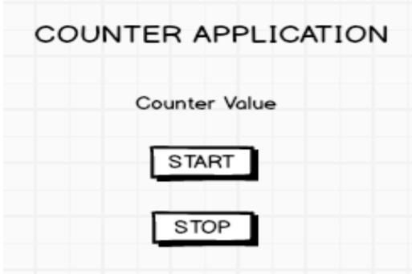

import 'dart:async';
import 'package:flutter/material.dart';

void main() => runApp(const CounterApp());

class CounterApp extends StatelessWidget {
const CounterApp({super.key});
@override
Widget build(BuildContext context) {
return MaterialApp(
title: 'Counter Application',
debugShowCheckedModeBanner: false,
home: const CounterHomePage(),
);
}
}

class CounterHomePage extends StatefulWidget {
const CounterHomePage({super.key});
@override
State<CounterHomePage> createState() => _CounterHomePageState();
}

class _CounterHomePageState extends State<CounterHomePage> {
int _counter = 0;
Timer? _timer;

bool get _isRunning => _timer?.isActive ?? false;

void _startCounter() {
if (_isRunning) return; // avoid multiple timers
setState(() {
_counter = 1; // start from One
});
// increment every 1 second
_timer = Timer.periodic(const Duration(seconds: 1), (timer) {
if (!mounted) return;
setState(() {
_counter++;
});
});
}

void _stopCounter() {
_timer?.cancel();
_timer = null;
setState(() {}); // update UI (buttons)
}

@override
void dispose() {
_timer?.cancel();
super.dispose();
}

@override
Widget build(BuildContext context) {
return Scaffold(
appBar: AppBar(
title: const Text('COUNTER APPLICATION'),
centerTitle: true,
),
body: Center(
child: Column(
mainAxisAlignment: MainAxisAlignment.center,
children: <Widget>[
const Text('Counter Value', style: TextStyle(fontSize: 20)),
const SizedBox(height: 12),
Container(
padding: const EdgeInsets.symmetric(horizontal: 24, vertical: 12),
decoration: BoxDecoration(
border: Border.all(width: 3),
borderRadius: BorderRadius.circular(6),
),
child: Text(
'$_counter',
style: const TextStyle(fontSize: 40, fontWeight: FontWeight.bold),
),
),
const SizedBox(height: 24),
ElevatedButton(
onPressed: _isRunning ? null : _startCounter,
child: const Padding(
padding: EdgeInsets.symmetric(horizontal: 28.0, vertical: 12.0),
child: Text('START'),
),
),
const SizedBox(height: 12),
ElevatedButton(
onPressed: _isRunning ? _stopCounter : null,
child: const Padding(
padding: EdgeInsets.symmetric(horizontal: 28.0, vertical: 12.0),
child: Text('STOP'),
),
),
],
),
),
);
}
}

